**ECEN 454**

**LAB 1**

**NAME:** Jason Gilman

**UIN:** 126006979

**SECTION:** 511

**TA:** Guaynu Gao

**Fulladder:**

Schematic - fulladder

Symbol - fulladder

Testbench – fulladder

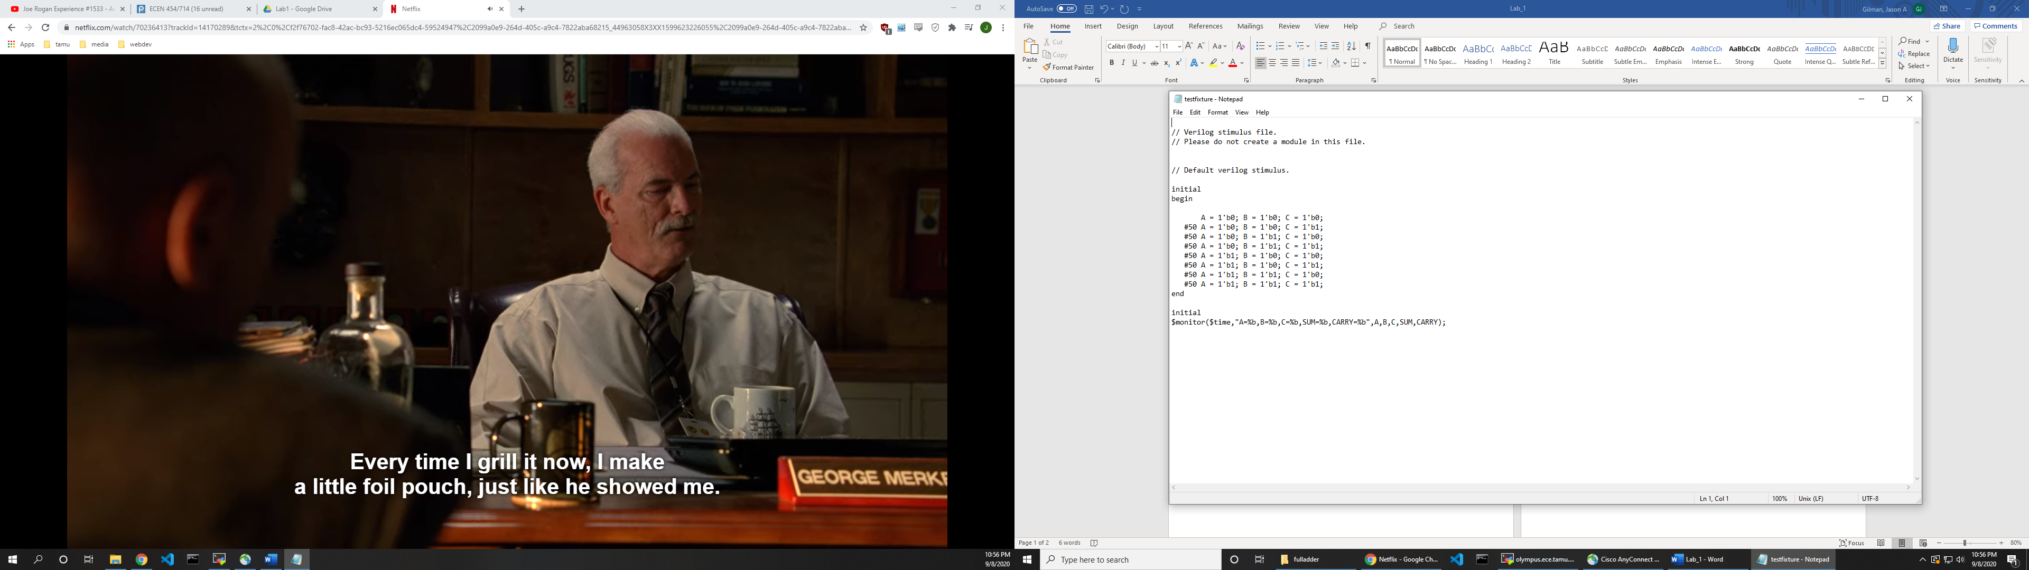

Simulation Output - fulladder

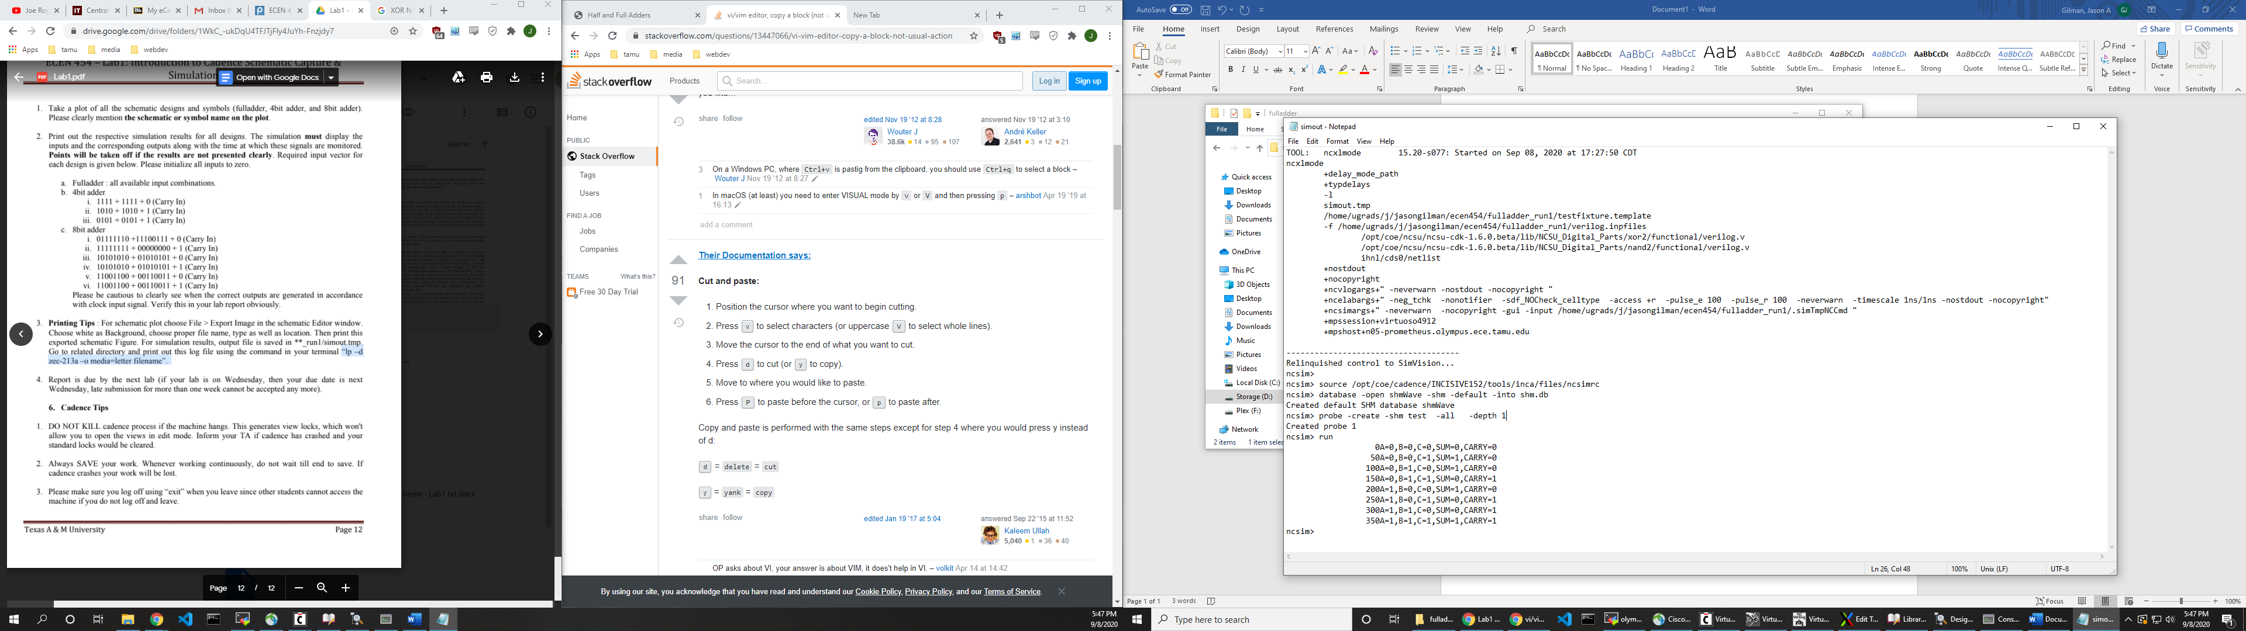

**4-Bit-Adder:**

Schematic – 4-bit-adder

Symbol – 4-bit-adder

Testbench – 4-bit-adder

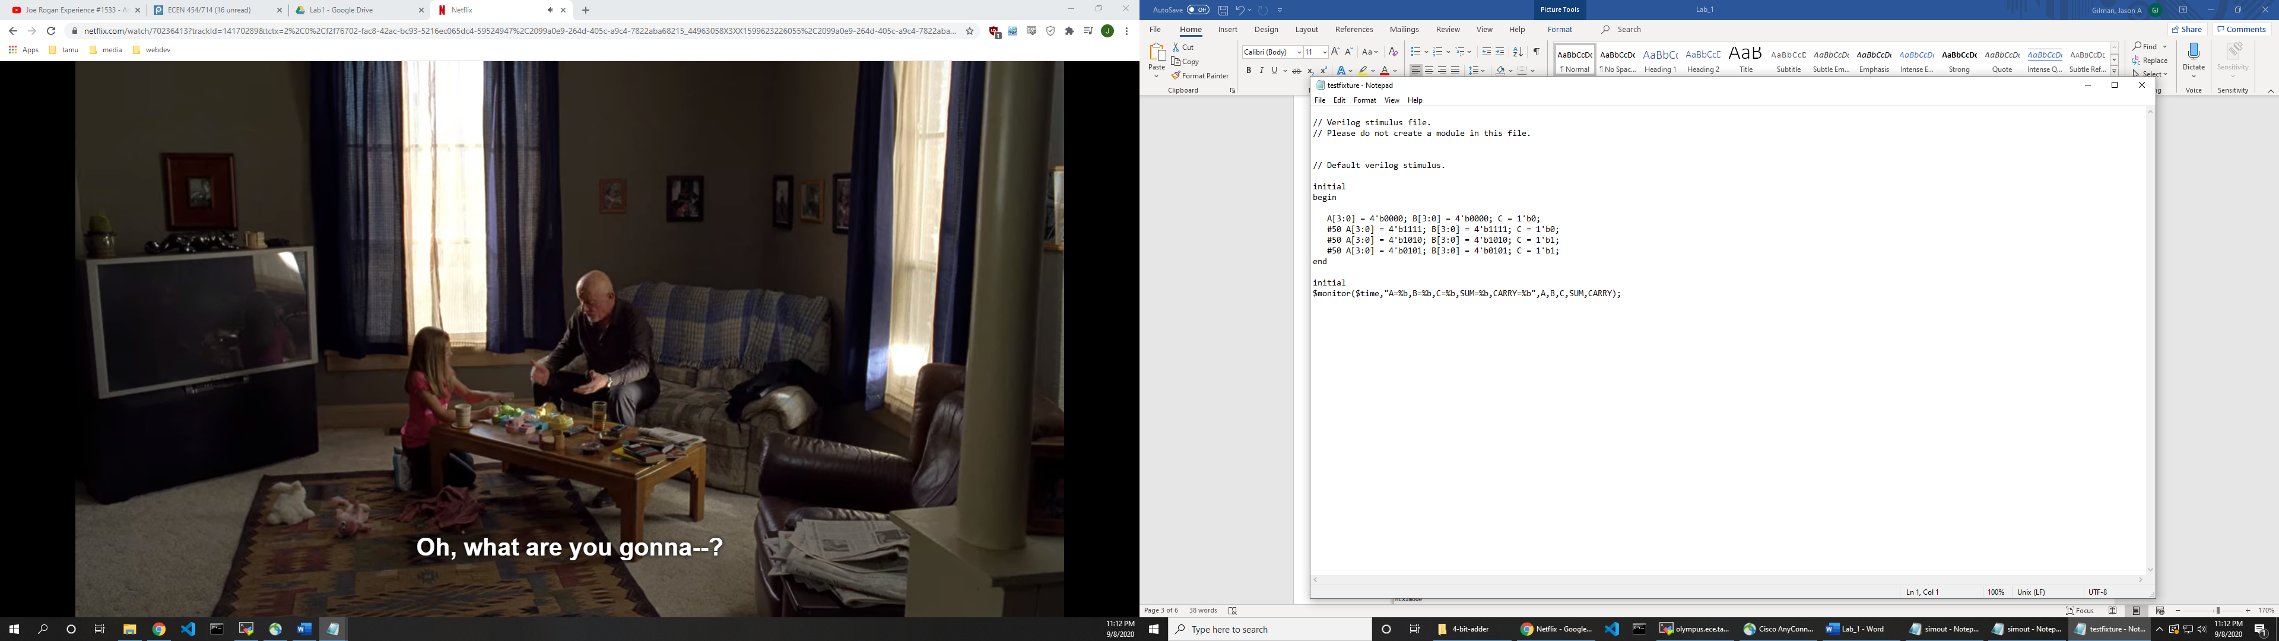

Simulation Output – 4-bit-adder

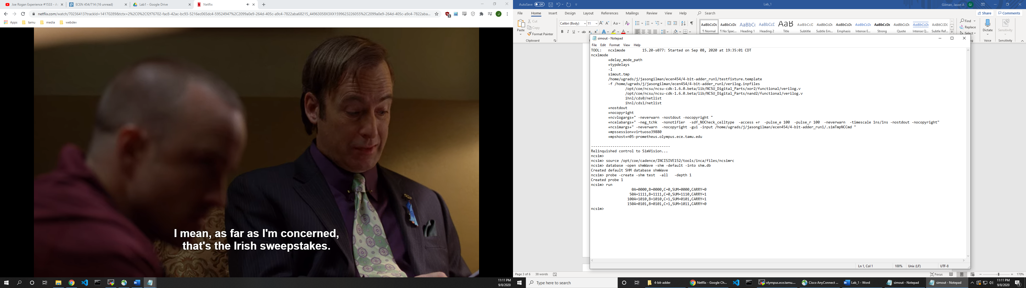

**4-Bit-Register:**

Schematic – 4-bit-register

Symbol – 4-bit-register

**8-Bit-Adder:**

Schematic – 8-bit-adder

Symbol – 8-bit-adder

Testbench – 8-bit-adder

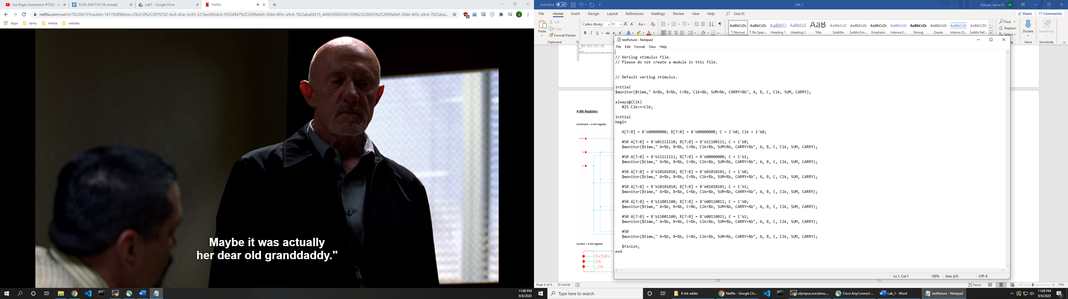

Simulation Output – 8-bit-adder

